- Open Telco-Customer-Churn.csv in Excel and use the Filter feature to count how many customers have Churn = 'Yes' and how many have Churn = 'No'.
ANSWERS:
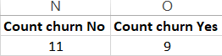

- Use Excel's PivotTable tool to analyze the relationship between Contract type (Month-to-month, One year, Two year) and Churn — show the count of churned customers for each contract type.
ANSWERS:
 | Column Labels
 | Month-to-month | One year | Two year | Grand Total
Count of Churn | 9 | 5 | 6 | 20

- Calculate the average MonthlyCharges for customers who churned versus those who did not using Excel's AVERAGEIF function.

Hint: Use =AVERAGEIF(range, criteria, average range) for both groups.
ANSWERS:
Avg Monthly Yes Charges | Avg Monthly NO Charges
67.31666667 | 75.63181818

- Create a bar chart in Excel that compares the number of churned vs non-churned customers for each InternetService type (DSL, Fiber optic, No).
ANSWERS:
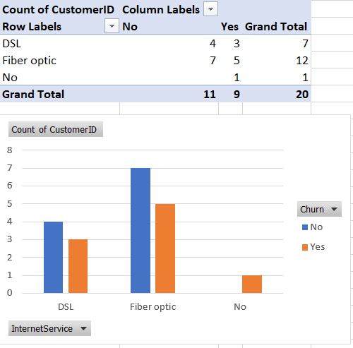

- Use Excel's CORREL function to check if there is a correlation between Tenure and Churn (convert Churn 'Yes' to 1 and 'No' to 0 in a new column first), and interpret the result.

Hint: Use =CORREL(array1, array2) after preparing the numeric column.
ANSWERS:
Column1
-0.849798498

